AASCU-JSI Project
June, 2008
Stephen Cole Leach
University of Texas Pan American

Introductory Narrative
My project was to devise a way of incorporating the philosophy of Japan into an undergraduate course in Eastern Thought. Although my basic competency was in Indian philosophy and, to a lesser extent, Chinese thought, my exposure to Japan had previously consisted solely in a superficial acquaintance with (Americanized) Zen and an untutored, but lifelong, interest in Japanese film. Hence, my original plan was simply to gain sufficient background knowledge to provide material for a few classes on aesthetics from a Japanese point of view. Almost immediately upon beginning the JSI sessions, however, I realized that a few classes would not be sufficient even to broach the topic I had decided to investigate, so rich was the field into which I had stumbled. At the same time, I began to reconsider my overall approach to Eastern Thought, which was thoroughly plenary and quite scholastic (qualities which had not passed unnoticed by my previous students.) When I considered the stultifying effect of my earlier approach to my topic, alongside the growing fascination with the ‘Japan’ which JSI was daily opening up to me, I knew that a drastic change was needed, not just in my contemplated syllabus, but in the very way I have been teaching all my courses.
Thus, I committed to a new plan: to introduce my students to the philosophy of Asia in toto by a focus only on a very few Japanese topics, hoping through insights gained in that way to inspire my students to a life-long interest in the lived philosophy of the East. I hope this will encourage them eventually to study all which I had to omit, but with a willing interest which my previous methods had failed to inspire. Instead of a compendium of details about ‘all- things- Asian, from A (atman) to Z (Zhuangzi)’, I have developed instead a course in applied philosophy, if you will, based on a few key Japanese principles. The course will be orderd, and assessed, accordingly. My hope is that this course will be not only informative but transformative, and result in the students having a new appreciation for them selves, those others whom they may chance to encounter in their journeys, and the beauty of the world they are blessed to inhabit. The skeleton, and a bit of the flesh, of this new approach follows.

University of Texas Pan American
Department of History and Philosophy
Eastern Thought: Philosophy 2370.01
Professor Stephen Leach

This course will consist of three overlapping modules which will introduce the student to distinctive ways of thinking and acting inspired by, structured by, and assessed by some basic principles of Japanese aesthetics. The course will terminate with a group presentation of creative projects. Brief descriptions of the modules, the final project required readings, and evaluative criteria follow.

Module One: Narrow Road to the Interior

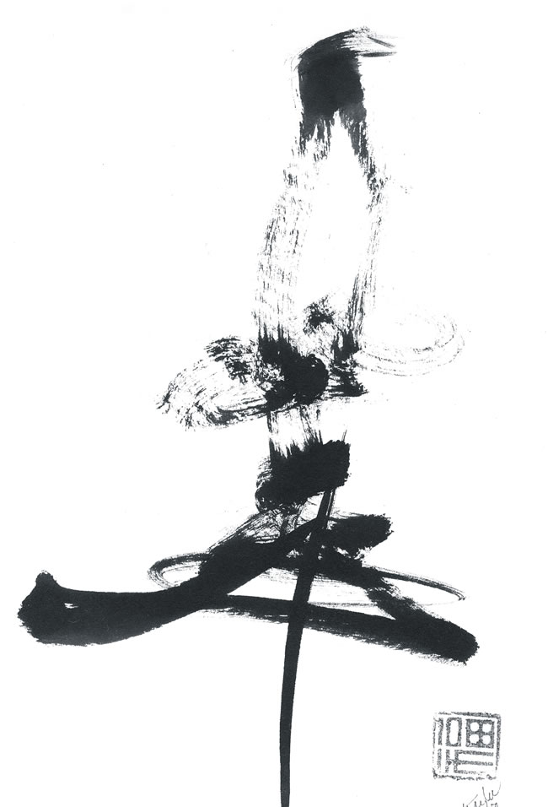

This module begins with some exercises at translating simple Japanese poems and culminates with a reading of Matsuo Basho’s travel journals, an exquisite blend of Haiku, prose poetry, and subtle philosophy. Along the way students will be introduced to the underpinnings of Basho’s life-view through brief analyses of the Tao Te Ching, the Zhuangzi, and the primary teachings of the Buddha.
The western analogues for this section of the course might be Aesthetics and Metaphysics/Ontology, with a focus on the value of place, the seasons, and the conceptual creation of space/time, and Enviromental Ethics.
Primary Text (Required): Basho’s Journey: The Literary Prose of Matsuo Basho, David Landis Barnhill, trans., Albany: State University of New York Press, 2005. (Note: all ancillary readings are posted free in .pdf format on the Blackboard page for the course.)
Recommended Texts: Our Library contains the following works (on reserve), suitable for advanced study; additional articles will be posted on the web page for our course.
The Essential Haiku: Versions of Basho, Buson, and Issa, Robert Hass, trans., Hopewell, New Jersey: The Ecco Press, 1994.
The Construction of Space in Early China, Mark Edward Lewis, Albany: State University of New York Press, 2006.
Basho and the Dao: The Zhuangzi and the Transformation of Haikai,
Peipei Qiu, Honolulu: University of Hawaii Press, 2005.
A Zen Wave: Basho’s Haiku and Zen, Robert Aitken, New York/Tokyo: Weatherhill, 1978.
Project: The students will learn cooperatively, working in small groups of three or five members. The assigned tasks are to understand enough of Basho’s philosophic art to be able to construct poems or prose pieces in the same vein, infused by the same philosophic insight, but specific to their locale and to the particular lives which they lead. The ultimate task for this module is the construction of three or five renku or linked verses, representing the collaborative effort of all members of the group. Criteria by which the results will be evaluated include (but are not limited to) the concepts of kanso, wabi, and yugen.

Module Two: The Way of Tea
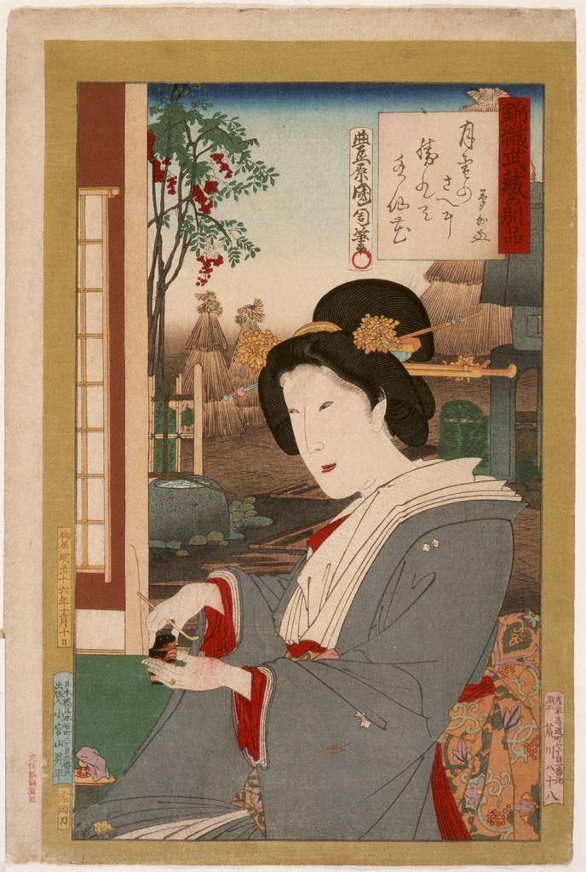

Through the ancient art of sado and related arts, we will attempt to come to an understanding of ritualized gesture and appropriate action. Along the way, students will be exposed to Confucian and Shinto concepts of moral cultivation, propriety, and the notion of the sacred.

The Western analogue to this section might be Ethics or Moral Philosophy.

Project: The students will “serve tea” to their “guests” by identifying some area of their lives which could serve as an appropriate forum for ritual perfecting, and share these rituals in groups of three or five. “Guests” will “thank” their hosts in writing, and this document will provide the basis of evaluating the student’s activity. Criteria by which the results will be evaluated include, but are not limited to, appropriateness of the chosen activity, thoughtfulness in preparing for it, and overall aesthetic quality of the performance.

Primary Text (Required): Rikyu (Film), Hiroshi Teshigahara, director, 1989.

Recommended Text: The Book of Tea, by Kakuzo Okakura, available on-line. (Note: all ancillary readings are posted free in .pdf format on the Blackboard page for the course.)

Module Three: Oblique Strategies



Through “sitting on” koans and through analyzing different concepts of liberation and enlightenment as manifested in the Indian, Chinese, and Japanese philosophic traditions, students will come to better appreciate these concepts in a cross-cultural perspective.
The Western analogues to this section of the course might be Epistemology and Philosophy of Religion.
Project: Students, working individually, will construct their own portable “koan-kit,” and provide instructions for its use, as well as a justification for their choices and methods of construction. Methods of assessment will vary depending on the nature of the student’s finished product, but the grounds for evaluation must be determined by the student him/her self.
Primary Text: Selected Upanisads, passages from the autobiography Wild Ivy by Hakuin, and selected koans, available in .pdf on the Blackboard page for our class.

Final Project

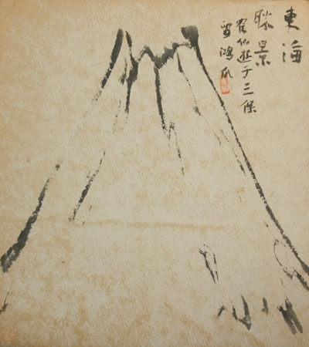

Final Project: Working in groups of five or seven, students will design, produce, and “market” a learning aid on some aspect of Eastern thought. This product must have a real market-base, be suitable for mass-production, inexpensive, and simple to use. Note: grades on this project will be shared by all members of the production team equally!

